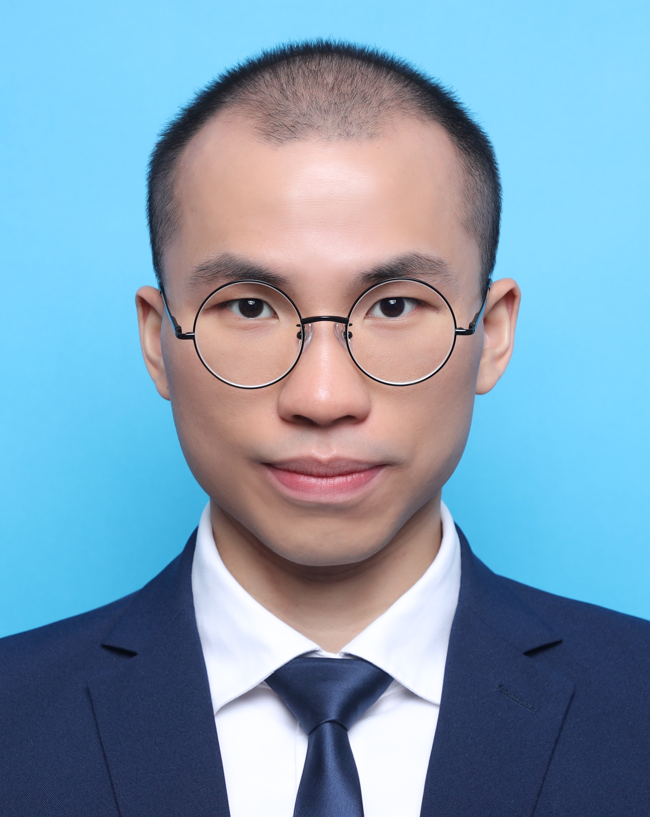
Autobiography

Name | : | LAM Pui-king (Tom) (林培景)
UI | :
Squad | : | PI 713

(a) Family background
I am Lam Pui-king (Tom), aged 28. My father had worked as a security before he passed away in 2023 from end-stage kidney disease. My mother currently works as a supervisor at a Chinese restaurant, and I have a little sister who is finishing her final year of secondary school. I live at HillTop Garden in Diamond Hill.
(b) Academic qualifications
I attended Jockey Club Government Secondary School from 2008 to 2011 (Form 1 - 3). I then continued my education at Boren Sino Canadian School, completing grades 10 to 12 from 2011 to 2014. I graduated with a Bachelor's degree in Financial and Business Economics from York University in 2019. After returning back to Hong Kong, I completed a Master's degree in Economics at the University of Hong Kong in 2023.
(c) Working experience
Upon completing my secondary school, I began working in various part-time jobs, including waiter and kitchen worker in both Hong Kong and Toronto. Following my university graduation, I transitioned myself into more specialized fields, ranging from securities dealing officer, data analyst, data engineer, and business intelligence analyst across multiple financial institutions and startup firm.
(d) Personal interests
I am passionate about playing basketball and reading books. Playing basketball has not only improved my physical health but also enhanced my strategic thinking and teamwork skills. Additionally, I have a keen interest in reading books about investing. I view investing as a lifelong journey and find it particularly rewarding to discover undervalued companies with potential for growth.
(e) Reasons for joining the HKP
My desire to join the force was influenced by witnessing a police officer save my neighbor from a suicide attempt when I was in early secondary school years. This experience cemented my belief that police work is not only a simple job to ensure public safety and tackling crimes but also a vital role in helping individuals during their darkest or hopeless moments. Moreover, I am drawn to the unique and dynamic nature of police work (from TVB episodes), such as investigating cases, apprehending criminals, and delivering justice to the victims. These aspects of the career are not only intriguing but also deeply rewarding.
(f) Any other matters you wish to mention
The journey to becoming a probationary inspector of police has been challenging and arduous for me. It took nearly five years and more than five attempts, including recalls at different stages, to finally get accepted to have a chance to undergo training at Police College. These experiences were invaluable, teaching me crucial lessons about resilience, perseverance, and the importance of continuous improvement from inner side. I deeply value and cherish this opportunity I have today, and I am committed to facing and overcoming the upcoming difficulties in my future career.
Word count: 501
2024-12-30

